

School of Future Tech

Case Study Report

on

CAR PARKING MANAGEMENT SYSTEM

by

BHUVISHA GOHIL

150096725190
Index
- Introduction to the Case Study.
- Problem Statement / Case Background (Abstract).
- Problem Statement / Case Study Design.
- Methods & Algorithms Technology Applied in the Problem Statement / Case Study.
- Problem Statement / Case Study Implementation Details and Snapshots.
- Problem Statement / Case Study Results and Conclusion.
- References

Introduction to the Case Study
With the increasing number of vehicles in modern cities, managing parking spaces has become an important challenge. Manual parking systems often create confusion, waste time, and lead to inefficient use of available parking slots.
A Car Parking Management System is designed to manage parking spaces in an organized way. The system keeps track of vehicles entering and leaving the parking area and helps allocate parking slots efficiently.
This project is developed using C++ programming language and demonstrates the use of object-oriented programming, file handling, and time functions. The system provides a menu-driven interface where users can park vehicles, remove vehicles, view parking slots, check parking summaries, and search for vehicles.
The objective of this project is to create a simple yet effective system that automates parking management and demonstrates practical programming concepts.

Problem Statement / Case Background (Abstract)
Parking management is a common issue in areas such as malls, offices, and residential complexes. Manual systems are often inefficient and make it difficult to track vehicles and parking availability.
Common problems include:
• Difficulty tracking parked vehicles
• Time wasted searching for parking slots
• Poor management of available parking space
• Lack of proper record maintenance
Problem:
Design a Car Parking Management System using C++ that can:
• Allocate parking slots automatically
• Record vehicle entry and exit time
• Display parking slot status
• Search for vehicles in the parking area
• Maintain parking records in a file
Abstract:
This case study presents a console-based Car Parking Management System implemented in C++. The system manages 15 parking slots and provides features such as vehicle parking, vehicle removal, slot viewing, parking summary, and vehicle search. The program records parking details including entry time and exit time and saves them in a file named parking_records.txt. The system also calculates parking fees based on ₹80 per hour.

Case Study Design

The Car Parking Management System is divided into different modules to organize the program effectively.

3.1 User Interface Module

The system uses a menu-driven interface that allows users to select operations easily.

Main menu options include:

Park Vehicle

Remove Vehicle

View Slots

Parking Summary

Search Vehicle

Exit

This interface allows users to manage parking operations in a simple and clear way.

3.2 Parking Slot Management Module

The system manages 15 parking slots. Each slot stores information such as:

• Slot number
• Vehicle number
• Parking hours
• Entry time
• Slot status (occupied or available)

The system automatically assigns the first available slot when a vehicle enters the parking area.

3.3 Vehicle Information Module

The system records important details about each vehicle including:

• Vehicle number
• Parking slot number
• Entry time
• Parking duration

This information is used to manage parking records and calculate parking fees.

3.4 File Handling Module

The system stores parking data in a file called:

parking_records.txt

Whenever a vehicle is parked or removed, the details are saved in the file. This helps maintain a record of parking activities.

Methods G Algorithms Technology Applied in the Problem Statement
/ Case Study

4.1 Parking Slot Allocation Algorithm
The program searches for the first available parking slot.
Algorithm Steps:
- User enters vehicle number and parking hours
- The system checks each slot
- If a slot is available, it is assigned to the vehicle
- Entry time is recorded
- Parking details are saved in the file
This ensures efficient parking space utilization.
4.2 Vehicle Removal Algorithm
When a vehicle leaves the parking area:
- User enters the vehicle number
- The system searches all parking slots
- If the vehicle is found, the slot is released
- Entry time and exit time are displayed
- Parking fee is calculated
The slot then becomes available for other vehicles.
4.3 Parking Fee Calculation
Parking fee is calculated based on the number of hours parked.
Formula:
Parking Fee = Hours Parked × ₹80
The system automatically calculates and displays the fee when a vehicle leaves.
4.4 Vehicle Search Algorithm
The system allows users to search for a parked vehicle.
Steps:
- User enters vehicle number
- The system checks all parking slots
- If the vehicle is found, the slot number and entry time are displayed
- If not found, the system shows a message
4.5 Technologies Used
• C++ Programming Language – Implementing system logic
• Object-Oriented Programming – Using classes and objects
• File Handling – Storing parking records
• Time Functions – Recording entry and exit time

Problem Statement / Case Study Implementation Details and Snapshots.

5.1 Parking Vehicle Implementation
When the user selects Park Vehicle:
• Vehicle number and parking hours are entered
• The system finds the first available slot
• Entry time is recorded
• Expected parking fee is displayed
• Data is stored in the file
5.2 Removing Vehicle
When a vehicle leaves:
• The user enters the vehicle number
• The system searches for the vehicle
• The slot is released
• Entry and exit times are displayed
• Parking fee is calculated
5.3 Viewing Parking Slots
This option displays all parking slots and shows whether they are:
• Occupied
• Available
The system also shows the number of available slots.

5.4 Parking Summary
This feature displays:
• Total parking slots
• Number of occupied slots
• Number of available slots
• Total parking earnings

5.5 Searching Vehicle
Users can search for a vehicle by entering its vehicle number.
The system displays the slot number and entry time if the vehicle is found.

5.6 Program Snapshots
Snapshots includes:
- Main menu of the program
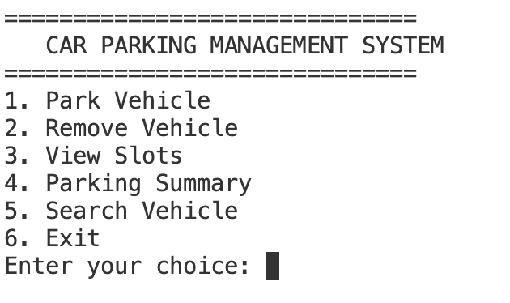
- Parking vehicle input screen
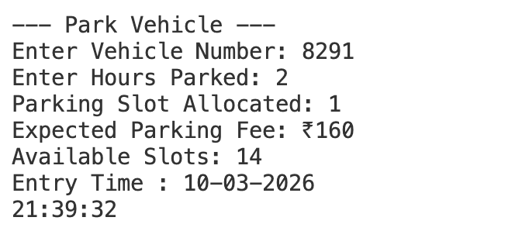
- Slot allocation output
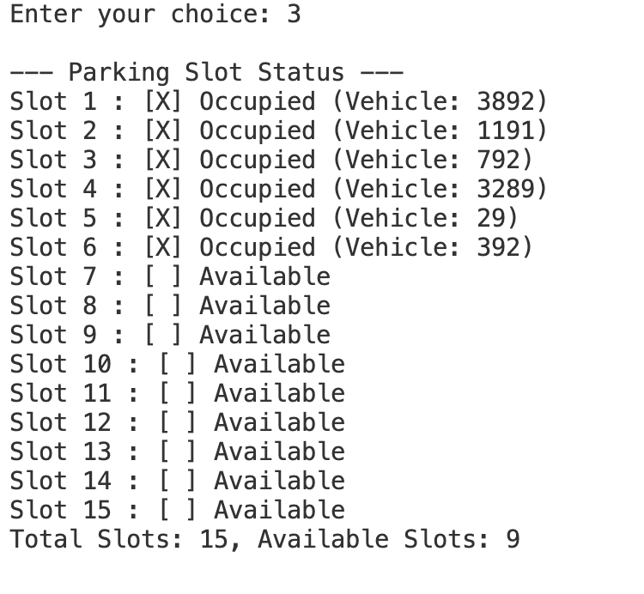
- Vehicle removal output
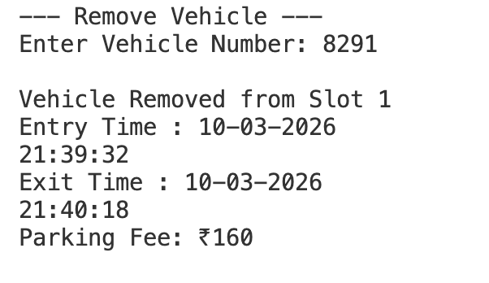
- Parking summary display
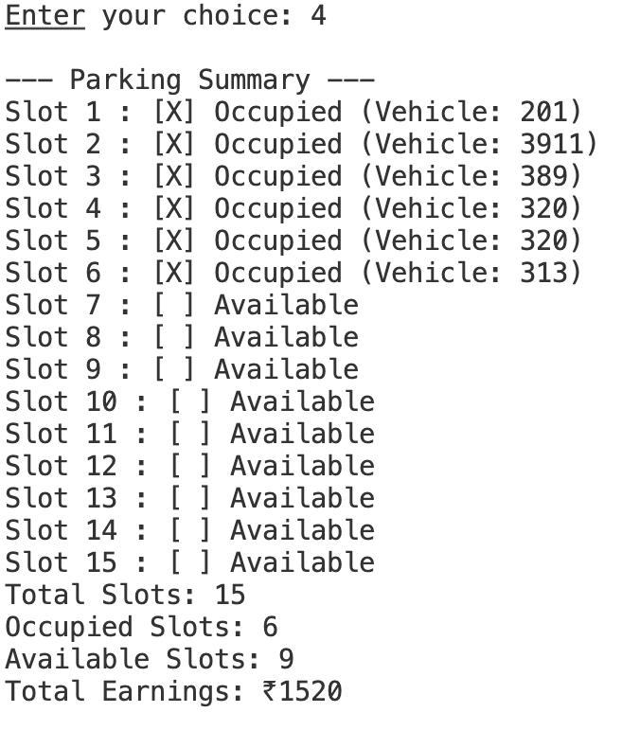
These snapshots help demonstrate how the system works.

Problem Statement / Case Study Results and Conclusion.

Results
The Car Parking Management System successfully demonstrates:
• Automatic parking slot allocation
• Tracking of vehicle entry and exit time
• Calculation of parking fees
• Display of parking slot availability
• Vehicle search functionality
• Storage of parking records using file handling

Conclusion
The Car Parking Management System provides a simple and efficient solution for managing parking spaces. The project demonstrates how programming concepts such as object-oriented programming, file handling, and logical algorithms can be used to solve real-world problems.
The system helps improve parking management by automating slot allocation, maintaining parking records, and calculating parking fees. This project highlights the practical application of C++ programming in building management systems.

References

• W3Schools – C++ Programming Tutorials
• GeeksforGeeks – C++ Concepts and Examples
• C++ Documentation
• Programming Logic and Algorithm Resources

